THE HIGT FREQUENCY COMPACT GENERATOR
OF ACCELERATING VOLTAGE ON 500kV, 10kW

A.A. Babkin, P.V. Bykov, G.S. Krainov,
G.I. Sil’vestrov, V.V. Shirokov and Yu. F. Tokarev

A cascade accelerating-voltage generator with inductive coupling and parallel power supply to the cascades is examined. The basic parameters and dimensions of a generator for a voltage of 500 kW and power 10 kW are presented.

The generator is designed to power a tandem charged-particle accelerator. Energy-stabilized (to within ±0.1%) charged-particle beams are used to study the structure of nuclei (resonance interaction of γ-rays with nuclei) and for solving the problems of using fast neutrons for therapeutic purposes.
The layout of the generator units is similar to that in the ELV accelerators [1]. The appearance of rf rectifier stacks (RHC manufactured by Electronic Devices Co., 2PF140 manufactured by Semtech Co., and KTs108V) and bipolar transistors with an insulated gate (IGBT) on the market has stimulated the development of an rf compact generator and switching the power supply frequency from 400 Hz to 20 kHz. The basic parameters of the accelerating-voltage generator are as follows:
Maximum voltage, kV..........………..................................... 500
Power, kW ............................................................................. 10
SF₆ gas pressure, MPa .......................................................... 0.2
Accelerating voltage pulsations under load, % ..................... 0.1
Coupling coefficient of the transformer windings …………. 0.68
Efficiency .............................................................................. 0.94
Inductance of the primary winding, H .................................... 17∙10⁻⁶
Inductance of the secondary winding, H ............................... 57.4
Characteristic frequency of the secondary winding, kHz..... 24.5

Description of the Generator. The cascade accelerating-voltage generator with inductive coupling and parallel powering of the cascades is a system of identical, serially-connected rectifiers - generator sections (Figs. 1 and 2). The mutual induction rectifiers are coupled with a common primary transformer winding T_{p}. All sections are assembled following a scheme with doubled voltage.
In the rectifying scheme, the transformer T_{p} charges, through diodes, a circuit consisting of n capacitors with the equivalent capacitance C_{d}/n to which the accelerator, which is the generator load R₁, is connected. The resistance which limits the extracted power is the leakage inductance of the transformer. The influence of the inductance in the charging circuit on the rectifier current is studied in [2, 3]. The expression for the average current per pulse for the limiting value U₂/e_{2m} = 0.537 is
$I_{2}=\frac{2}{π}\frac{U_{2}}{(1−k^{2}){ωL}_{2}},$

where U₂ is the total voltage of the windings of the rectifiers (sections) under load; e_{2m} is the total emf of mutual induction with no load; k is the inductive coupling coefficient between the primary and secondary windings;

Fig.1. Accelerating-voltage generator: 1) ring; 2) secondary winding; 3) 50 rectifying sections; 4) vessel; 5) water cooling; 6) power input; 7) magnetic circuits; 8) screen; 9) primary winding; 10) bigh-voltage electrode.

Fig.2. Schematic diagram of the generator: T_{p} – transformer without the central core, the ratio of turns is 9/21,700; L₁ – primary winding without a copper tube, 6x0.5 dimensions, parallel 4 branches; L₂ – 50 coils each with 434 turns; M – mutual inductance 2.3⋅10⁻²H; A₁ - A_{n} – rectifying sections (n = 50); VD – KTs108V diode columns, two each in the arm in series; C_{d} – ceramic capacitors K15-5 (4700 pF, 6.3 kV), multiple-series 8 units per section; R₁ – TVO-2 (100 Ω); R₂ – C3-14 (100 Ω), 100 units; C_{q} – parasitic interwinding capacitance.

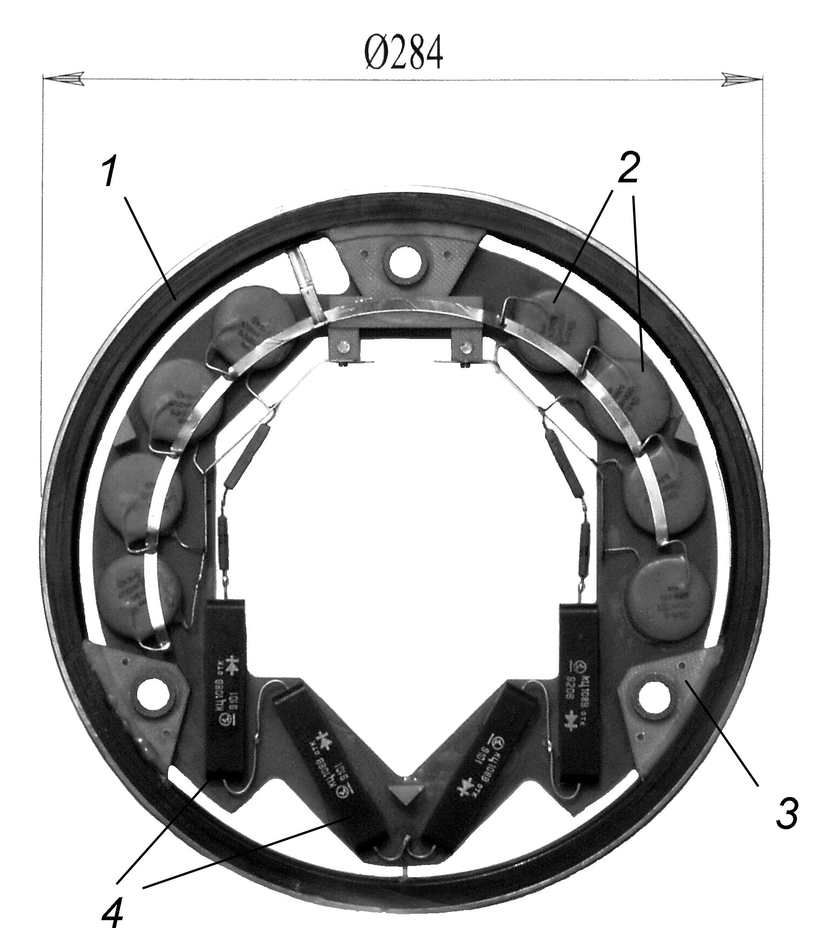

Fig.3. Rectifying section: 1) coil; 2) capacitor; 3) support (11 mm height); 4) KTs108V diodes.

ω is the angular frequency; L₂ is the total inductance of the sections. The maximum value U₂/e_{2m} = 0.537 corresponds to a regime where the duration of the current pulses through the diode reaches the maximum value π/ω. Analysis of the operation of this scheme shows that the maximum power transmitted to the load (accelerator) with U₂/e_{2m} is 0.5. When the voltage under load drops to the level 0.537 times the no-load voltage, the voltage U₂ assumes a square shape. Then the power P₂ transmitted to the load is
$P_{2}=\frac{2}{π}\frac{U_{2^{2}}}{(1−k^{2}){ωL}_{2}},$
For a rectifying scheme with doubled voltage, U₂ = U/2 and I₂ = 2I, where U and I are the given voltage and current of the rectifier respectively.
Figure 3 shows the construction of the rectifying section. The coil - a section or the secondary winding of the transformer - serves as the base on which all components of the rectifying scheme are assembled. The coil, which has a diameter of 284 mm and a transverse cross section 7.5 x 15 mm, has three glass-fabric-base laminate supports to which a 0.5 mm thick plate, on which capacitors and diodes are glued is secured. An 11-mm high centering bushing is glued into each support. The sections are joined to one another with the aid of the bushings. The coil is designed for a voltage of 5 kV and has 434 turns, consisting of 0.22 mm in diameter PEV-2 wire. Paper serves as the interlayer insulation; the entire coil is permeated with an epoxy compound using the "monolith" method. A thin stainless steel screen covers the coil on the outside; the output from the screen is connected by a 0.5 x 5 mm bus with the center point of the K15-5 capacitor.

Effect of transformer secondary coil capacity on load characteristics. Equivalent electric scheme of generator in this case looks like following (Fig.4). Secondary self-capacitance C₂ in the electric circuit results in intervals in charging current in every half-cycle of supplying voltage. During these intervals only recharge of C₂ capacity takes place. Under condition, the processes at the same scheme were studied in [3] for various values of relative circuit frequency , which is determined by correlation .

Fig. 4. Equivalent electric scheme of generator: R_{L} – load resistance, calculated to the secondary circuit; (1-k²)L₂ - short circuit inductance; C₂ – capacity of consecutive combinsted secondary coils; 1 - voltage multiplier.

In Fig. 5, load characteristics for boundary values of relative frequency (μ*=1, μ*=∞) and μ*=1.5, μ*=2 are shown; the frequency μ*=1.5 are about to fit the case. Short circuit current for transformer secondary, which is determined as
, was assumed here to be base current.
Fig. 5. Generator load characteristics at various values of relative frequency

μ*=2 is an optimum relative frequency, when generator resonance frequency is twice as much that source frequency. In this case, load current change slightly effects on output voltage.

Substantiation of the Basic Dimension of the Generator. The high-voltage gap is determined by the electric strength of the SF₆ gas insulation, making in possible to work with electric fields ~100 kV/cm. A 65 mm gap corresponding to this field strength was chosen taking account of the non uniformity of the field between the windings. The primary winding is made to be conical in order to increase the coupling coefficient between the transformer windings. It is known from experience in designing ELV-type accelerators that a coupling coefficient of the windings k=0.6÷0.7 is attained with d = (5÷6)∆_{c} where d is the diameter of the rectifier stack and ∆_{c} is the arithmetic-mean value of the gap between the windings. In rectifiers with similar construction the voltage gradient along the height of the rectifier stack does not exceed 8-9 kV/cm. The gradient is limited by the electric strength of the coils in the secondary winding of the transformer. In the case at hand, the voltage gradient additionally limits the height of the K15-5 filtering capacitors and the dimensions of the diode stacks. Consequently, at 500 kV the rectifier stack is 560 mm high und therefore the gradient for increasing voltage ~9kV/cm.
Conclusions. Increasing the power supply frequency permits increasing the specific power of the generator 80 kW/m³, which is mach greater that the currently achieved level. The pulsations or the accelerating voltage at full current are ~0.1%. In addition, the quality factor of the primary winding and therefore the efficiency of the generator increase as $\sqrt{ω}$.
REFERENCES
1. G. I. Budker. V. A. Gaponov, B. M, Korabel'nikov, el al., "ELV-1 electron accelerator for commercial use" Energ., 46 No. 3, 216-220 (1976).
2. B. I. Al’bertinskii and M. P. Svin'in, Casade Generators, Energoatomizdat, Moscow (1980). pp. 58-60.
3. B. A. Knysh, Semiconductor Transducer in Systems of Reservoir Capacitors, Energoatomizdat, Leningrad (1981). pp. 25-26, 30-31, 73-88.

